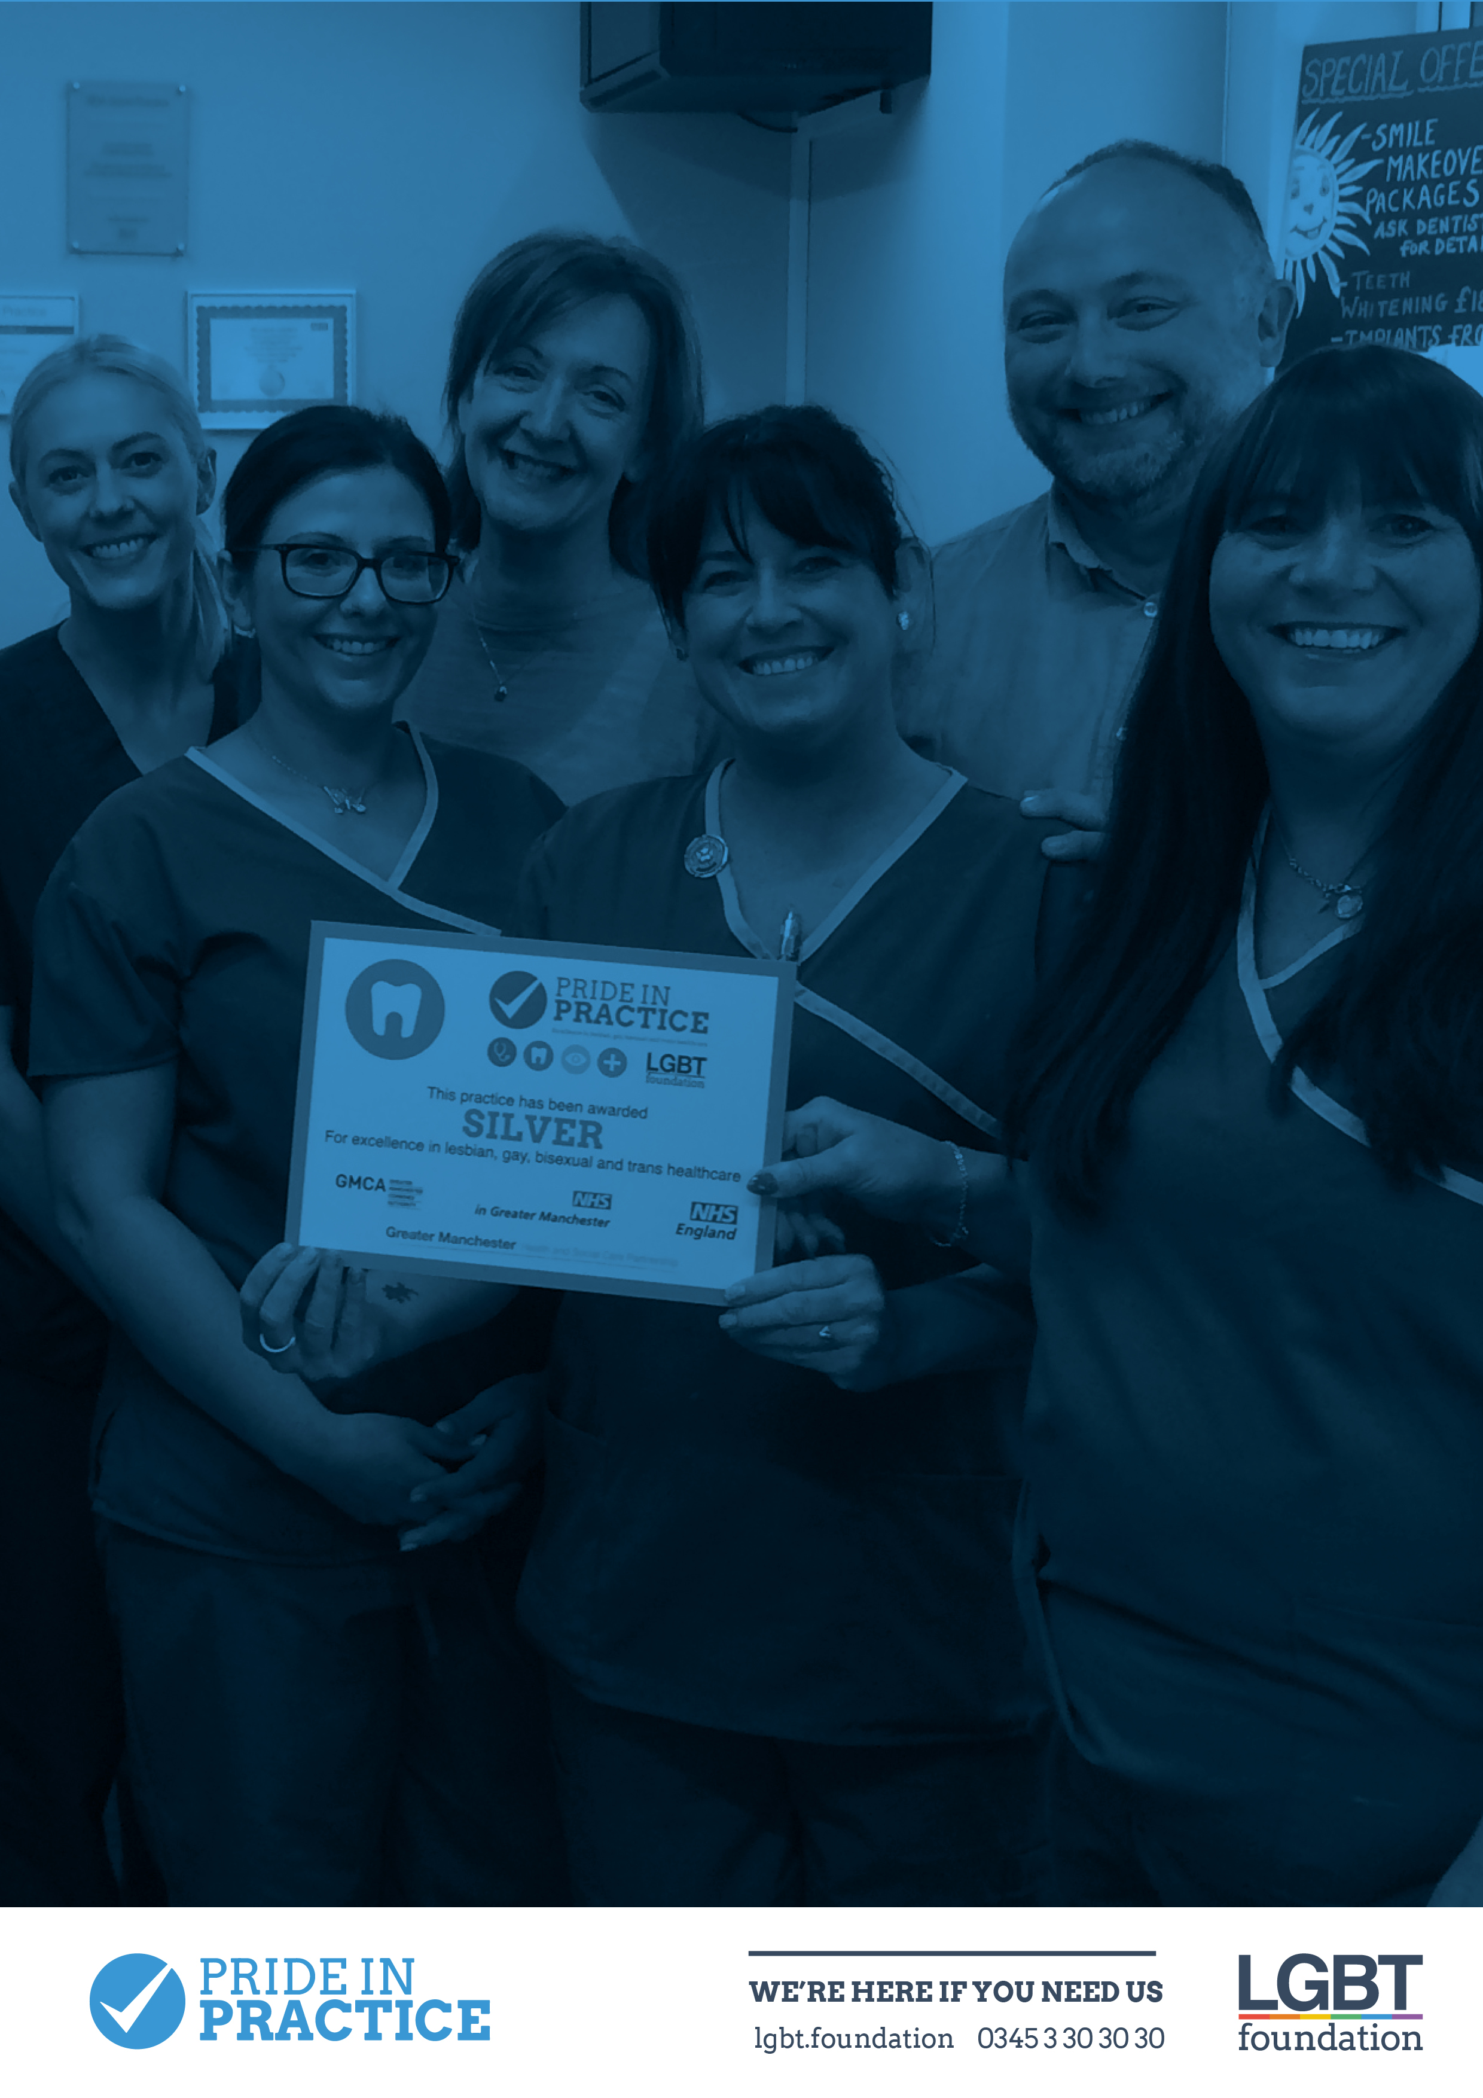
CONTENTS

Cancer 3

Dementia 4

Domestic Abuse 5

End of Life Care 6

Families & Fertility 7

HIV 9

Mental Health 10

Sexual Health 11

Substance Use (drugs, chemsex, alcohol & smoking) 12

CANCER

Breast Cancer Care UK

Lesbian and bisexual women and breast cancer

Cancer Research

Anal Cancer Statistics
Breast Cancer Statistics

Gynae Health UK

www.gynaehealthuk.com – home testing kits for cervical screening

Jo’s Trust (Cervical)

www.jostrust.org.uk

NHS

Anal Cancer

Breast Cancer

Cervical Cancer

Cervical Screening - Helping You Decide (multiple languages)

Prostate cancer

Prostate Cancer UK
Prostate Facts for Gay and Bisexual Men

Can trans women get prostate cancer?

Are you at risk?

What is my risk?

Useful Articles for Healthcare Professionals

Macmillan - The Emerging Picture; LGBT People with Cancer

Macmillan - Supporting LGBT people with cancer

Exploring the needs of gay and bisexual men dealing with prostate cancer

Cancer and the LGBT community

Understanding Transgender Men’s Experiences with and Preferences for cervical cancer screening: A Rapid Assessment Survey
DEMENTIA

Alzheimer’s Society
LGBT: Living with Dementia
Supporting an LGBT person with Dementia

National Care Forum

Dementia Care and LGBT Communities

Foundations for the future: Dementia Care and LGBT Communities

Dementia Statistics

Different Types of Dementia

Over the Rainbow

LGBT People and Dementia Project Summary Report

Useful Articles for Healthcare Professionals

Dignity in Care

Dementia and the LGBT population

Dementia Caused by Chronic Drug Addiction

DOMESTIC ABUSE

Broken Rainbow Helpline

0300 999 5428 | https://www.brokenrainbow.org.uk/help/helpline/

Galop/National LGBT Domestic Abuse Helpline

0800 999 5428 | www.galop.org.uk/domesticabuse

LGBT Foundation

0345 3 30 30 30 | lgbt.foundation/dasupport | dasupport@lgbt.foundation

Men’s Advice Line
0808 801 0327 | www.mensadviceline.org.uk

National Domestic Violence Helpline
0808 200 0247 | www.nationaldomesticviolencehelpline.org.uk

Useful Articles for Healthcare Professionals

What is domestic abuse?

Myths and stereotypes about violence and abuse in same-sex relationships

Domestic violence and abuse and the LGBT communities

Domestic abuse under the law

Transgender People’s experiences of Domestic Abuse

END OF LIFE CARE
Marie Curie
Hiding who I am - the reality of end of life care for LGBT people

MacMillan

NHS National End of Life Care Programme

The National Council for Palliative Care
The National Council for Palliative Care - LGBT

Useful Articles for Healthcare Professionals

CQC May 2016 Report
Working with older lesbian, gay and bisexual people: A Guide for Care and Support Services

FAMILY & FERTILITY

NHS

LGBT Paths to Parenthood

Human Fertilisation and Embryology Authority

Fertility Preservation for trans and non-binary people

Gov.uk

Surrogacy and Legal Services

Surrogacy Guidance for Healthcare Professionals

Stonewall

LGBT Parenting Rights

Pregnant Pause (guide for lesbians on how to get pregnant)
A Guide for Gay Dads

The Proud Trust
www.theproudtrust.org – A Manchester based organisation providing support groups for younger trans people. Their website also contains resources and information that may be helpful for services.

Surrogacy UK

www.surrogacyuk.org – Resources and guidance for professionals, intended parents and surrogates

New Family Social

www.newfamilysocial.org.uk – Simple information and research regarding adoption and fostering options for prospective LGBT parents

Proud 2 B Parents

www.proud2bparents.co.uk – legal advice, parenting/support groups, parenting options etc. The resources page has a plethora of signposting links for potential parents and professionals

FFLAG
www.fflag.org.uk – A national voluntary organisation and charity dedicated to supporting parents and their lesbian, gay, bisexual and trans children

Pride Angel
www.prideangel.com – Helps prospective parents find their own private donor or co-parent. In addition to providing fertility support, health screening and legal advice

We are Family
www.wearefamilymagazine.co.uk – A magazine dedicated to LGBT families, families-to-be and families with LGBT members

Three Circles Fostering
www.threecirclesfostering.com/resources – Information for LGBT fostering and trans youth in foster care

Gay Families in the Making
www.gayfamiliesinthemaking.wordpress.com – blog with a variety of further signposting links

Mermaids

www.mermaidsuk.org.uk – Support for young trans people and their parents, specifically around gender issues

Useful Articles for Healthcare Professionals

Beyond Babies and Breast Cancer

HIV

LGBT Foundation

lgbt.foundation/hiv | lgbt.foundation/hiv/living-with-hiv

lgbt.foundation/prep | lgbt.foundation/pep

AIDS Map
Protective measures
Post-exposure prophylaxis (PEP)

George House Trust
0161 274 4499 | www.ght.org.uk

Prepster
prepster.info

HIV Home Testing Kits
test.hiv

Prevention Access Campaigns – Undetectable=Untransmittable
www.preventionaccess.org/resources

Terrence Higgins Trust
0808 802 1221 | www.tht.org.uk

Useful Articles for Healthcare Professionals
Transgender people, HIV and AIDS
HIV and AIDS in the United Kingdom (UK)
Managing HIV-positive individuals in Primary Care
British HIV Association (BHIVA) 2018 Standards of Care
British HIV Association (BHIVA) current guidelines
National Institute for Health and Care Excellence (NICE) 2016/17 Guidance
National Institute for Health and Care Excellence (NICE) Encouraging HIV Testing

MENTAL HEALTH

LGBT Foundation

0345 3 30 30 30 | therapy@lgbt.foundation | helpline@lgbt.foundation

Mind
Guides to Support

Mind Out

www.mindout.org.uk

NHS England
Mental Health Issues for LGB People

Useful Articles for Healthcare Professionals

Mental health issues if you’re gay, lesbian or bisexual

RaRE LGBT Mental Health Report

London Assembly LGBT+ Mental Health Report

Dual diagnosis toolkit – Mental health and substance misuse

LGBT Suicide Prevention Toolkit

Mental health challenges within the LGBT community

LGBT inclusive mental health services; A guide for health and social care providers

Mental health in the LGBT community

SEXUAL HEALTH

LGBT Foundation

0345 3 30 30 30 | lgbt.foundation/sexualhealth | sexualhealth@lgbt.foundation

CliniQ
Cruising: A trans guy's guide to the gay sex scene

Terrence Higgins Trust (THT)
Trans Women Sexual Health
Trans Men Sexual Health

Passionate about Sexual Health (PASH)
www.gmpash.org.uk – Information on STIs, contraception and abortion – Manchester specific

NHS
Sexual health for gay and bisexual men
Are sex toys safe?
Lesbian and Bisexual Women's Health

Can you have sex during a period

Lesbian STD

www.lesbianstd.com – Sexual health information that specifically affect women having vaginal sex

LGBT centre for health and Wellbeing

Information for lesbian & bisexual women on cervical screening

Oxford Vaccine Group

Human Papillomavirus (HPV)

Useful Articles for Healthcare Professionals
Sexually transmitted infections of the anus and rectum
Sexually transmitted Infections and Chlamydia Screening in England
Promoting the health and wellbeing of gay, bisexual and other men who have sex with men
A Study of LGB Women's Attitudes to Cervical Screening

SUBSTANCE USE

LGBT Foundation

0345 3 30 30 30 | lgbt.foundation/substancemisuse

The Northern Sexual Health
Chemsex Support

Dean Street
ChemSex: A published, working definition

Terrence Higgins Trust
Friday/Monday – Information about chemsex, risks, safety and sources for support

GMFA
https://www.gmfa.org.uk/Pages/Category/safer-chems – Advice on having chemsex safely

Public Health England
Substance misuse services for men who have sex with men involved in chemsex

Useful Articles for Healthcare Professionals
Proud2BSmokefree Report
Improving health equality for gay, bisexual and other MSM – why now and how?
PHE action plan tackles health inequalities for men who have sex with men
Tobacco use in LGBT communities
Part of the picture: Lesbian, gay and bisexual people’s alcohol and drug use in England
Dual diagnosis toolkit: Mental Health and substance misuse
Promoting the health and wellbeing of gay bisexual and other men who have sex with men
Transgender Inclusion in Drug and Alcohol Services

